30/08/19

* Convert defaulted into factor
  + Took out “mths_since_last_delinq” which we think it’s quite important
* Convert revol_util into numbers
* Convert credit line into date
* Convert repay_fail into factors
* Getting rid of zip code, address, and subgrade
* Split data into training and validation
* Fit glm → with training data - binomial
* Run Summary(fit)
* Predict

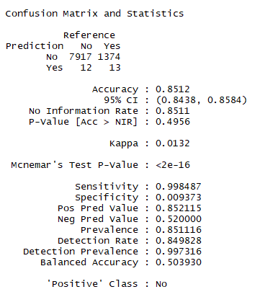

Can see that we didn’t treat the earliest credit line properly. Max Years is 2068 which is impossible.

